Week beginning 22.02.21 & 01.03.21
Year Group: Nursery (January intake)
We would love to see what learning you’ve been doing at home! Please send photos in using the Evidence Me app. We also have a Nursery twitter page (@NurseryUmps) where you can share your learning with us and the rest of the school.
Daily tasks | Phonics:  - Go onto google for phase 1 phonics game: type letters and sounds phase 1 phonics  Click ‘sound starter’ game. Click each button and listen to the sound. See if your child can identify the sound.  If you cannot access the internet, then perhaps you could hide some objects under a blanket and shake the object so that your child can listen and identify what the sound might be.  Practise every day, aim to recognise and remember the different sounds.  Reading:  Parents to share a book with children daily. Visit Oxford Owl for free eBooks. You can create a free account.  Complete the linked Play activities for each book.  Listening and attention  Play a game to help improve your child’s listening and attention skills  Ask your child to clap when you say stop they stop clapping. Then when you say ‘go’ they can clap again until you say stop.  Ask your child to hold something light like a small piece of paper or a feather on the palm of their hand and you say ‘ready steady…blow!” But they can only blow the paper/feather off their hand when you say blow. So Children need to wait until you say blow. Try to lengthen the time each time so they practice being patient and wait for your instruction.
Weekly Maths Tasks |  | Weekly Reading and Writing Tasks
Number Activities:  - Practise counting up to 5  0 1 2 3 4 5  Learn and recognize numerals 0 and 1  Practice forming these numbers using different media e.g. pencil, felt tip, sand, foam, chalk.  Ask your child if they can show you 1 finger, 2 fingers, when you say the number.  Say: Put your hand behind your back, now can you show me 1 finger. Put your hands behind your back, now can you show me 2 fingers? Can you show me 3 fingers?  Sing the song:  Five little ducks went swimming one day  Five little ducks went swimming one day  Over the hill and far away  Mother duck said, "Quack, quack, quack, quack"  But only four little ducks came back  One, two, three, four  Four little ducks went swimming one day  Over the hill and far away  Mother duck said, "Quack, quack, quack, quack"  But only three little ducks came back  One, two, three…continue until no little ducks came swimming back  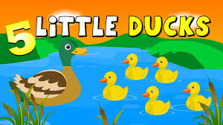 |  | Share a story with your story  - After you have read the same story a few times ask questions about the story as you read with your child e.g.  What did the character say?  What happened at the beginning of the story… middle…?  What might happen at the end of the story?  What do you like about the story?  - Asking questions...what, where, who  Your child should be able to ask questions such as…  What is that? (can name an object)  Where is…? (either a name or object)  Who is that?  Can your child use word endings correctly?  Such as going, cats, played  Writing/ Physical development  Help your child to practice drawing lines and circles using different materials such as chalk, felt tips, in the sand, in foam, in the air with their arms.  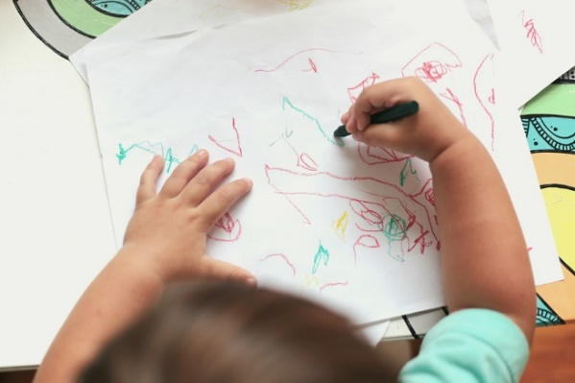  Then can they give meaning to the marks they make? Such as “that’s me and that’s mummy.”  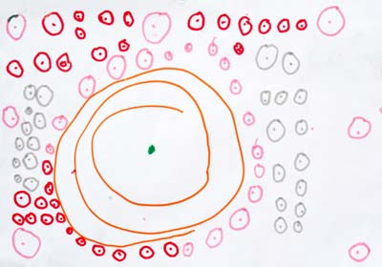  Then can they draw a picture and say what they have drawn?  Can your child fill in the missing word or phrase in these well- known nursery rhymes?  Twinkle Twinkle Little Star  Twinkle twinkle little ……  How I wonder what …. ……?  Up above the world so …….  Like a ………. In the ……….  Twinkle twinkle …… ……..  How I wonder what …. ……?  Humpty Dumpty  Humpty Dumpty sat on a ....  Humpty Dumpty had a great ….  All the king’s …… and all the king’s men  Couldn’t put ……. …….. again!
Twinkle Twinkle Little Star

Twinkle twinkle little star
How I wonder what you are?
Up above the world so high
Like a diamond in the sky
Twinkle twinkle little star
How I wonder what you are?

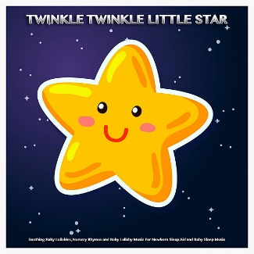

Humpty Dumpty

Humpty Dumpty sat on a wall
Humpty Dumpty had a great fall
All the king’s horses and all the
king’s men
Couldn’t put Humpty together again!

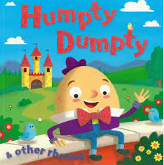

Checklist for January intake children

Practice this with your children over the next coming weeks.

- I can take my coat off by myself.

- I can put my coat on by myself.

- I can go to the toilet by myself.

- I can wash my hands all by myself.

- I can speak in simple sentences and communicate my needs e.g. I need the toilet. I like… I want…. etc.

- I can understand simple questions such as ‘What is that…?” “Where is the….?” “Who is….?”

- I can ask simple questions such as ‘What is that…?” “Where is the….?” “Who is….?”

Hope to see you soon!

